Software Design Specification

<Lost and Found Portal>

Internal Advisor:
• Admin
• Manager
• System Administrator
• Moderation Team
• Developers

External Advisor:
• Users (Item Owners / Finders)
• Students
• Software Consultants
• Maintenance Team

Project Manager:

- Malaika Hamid
- Eisha Fatima
- Manahil Fatima

Project Team:

- Malaika Hamid
- Eisha Fatima
- Manahil Fatima

Submission Date:

_____________________
Project Manager’s Signature

Document Information

Category | Information
Customer | UOS – Department of Computer Science
Project | Lost and Found Portal
Document | Software Design Specification
Document Version | 1.0
Identifier | SDS_ project _ group_10_LFP
Status | Draft
Author(s) | Malaika Hamid , Eisha Fatima ,Manahil Fatima
Approver(s) | Malaika Hamid ,Eisha Fatima , Manahil Fatima
Issue Date | Nov 20, 2025
Document Location | Stored in project Github repository
Distribution | - Dr.Illyas  - Malaika Hamid , Eisha Fatima , Manahil fatima  - UOS- Deapartment of Computer Science

Definition of Terms, Acronyms and Abbreviations
This section should provide the definitions of all terms, acronyms, and abbreviations required to interpret the terms used in the document properly.

Term | Description
UOS | University of Sargodha
SDS | Software Design Specification
UI | User Interface
OOD | Object- Oriented Design
DB | Data Base

Table of Contents

1. Introduction 4
1.1 Purpose of Document 4
1.2 Project Overview 4
1.3 Scope 4
2. Design Considerations 4
2.1 Assumptions and Dependencies 4
2.2 Risks and Volatile Areas 4
3. System Architecture 4
3.1 System Level Architecture 4
3.2 Sub-System / Component / Module Level Architecture 5
3.3 Sub-Component / Sub-Module Level Architecture (1…n) 5
4. Design Strategies 5
4.1 Strategy 1…n 5
5. Detailed System Design 5
6. References 6
7. Appendices 6

Introduction
This section introduces the purpose and the background of the Lost and Found Portal.

Purpose of Document
The Purpose of this document is to clearly explain how the Lost and Found Portal will be built. It gives the complete picture of the system structure,design,decision,database models and how different modules work together.This document will help developers understand what they need to implement,advisors understand whether the project is going in the right direction and testers understand how the system should behave.
Intended Audience:
Internal Advisor :
External Advisor:
Project Manager :
Development Team:
Testing and QA Team:

Design Methodology used:

This project uses Object -Oriented Design(OOD).Since the Portal contains real -world entities like Users,Items,Reports and Notifications.OOD allows us to organize everything into clean,reusable classes.This also makes the system easier to maintain and expand later.

  - Project Overview
The Lost and Found Portal is a web-based system designed to help students,faculty and staff report lost and found items easily. Whenever someone submits information about an item, the system matches it with the existing records and notifies the user if a match is detected.
This design follows a simple layered structure:

Fronted (Ul) Backend Logic Data Base

  - Scope :
The System Will cover:
- User login/signup
- Reporting Lost item
- Reporting Found item
- Searching through items
- Admin panel for managing reports
- Notifications for matched items
The System Will not cover:
- Live item tracking
- Automatic image recognition
- Physical verification of items
- Mobile app version(web-only project)

Design Considerations
This section describes many of the issues which need to be addressed or resolved before attempting to devise a complete design solution. In other words, this section is used to formally set the groundwork for the system design.

  - Assumptions and Dependencies
- Users will login with valid credentials.
- The system requires internet connectivity.
- The database server must remain active.
- Browsers need to support standard HTML/CSS/JS.
- Admin will manually review suspicious reports.

2.2 Risks and Volatile Areas
- User-entered descriptions may be incomplete.
- Browser updates might affect UI.
- Increased Traffic could slow the system.
- Future requirements changes might require redesign.
- Fake accounts or spam reports may require stronger security.

System Architecture

This section explains how major components of the system connect and interect.

3.1 System Level Architecture
Fronted : Login, forms, item listing
Backend: Logic for matching , storing , retrieving and validating
Database:Stores reports , users , Notifications

Flow:User UI Backend Database Backend UI
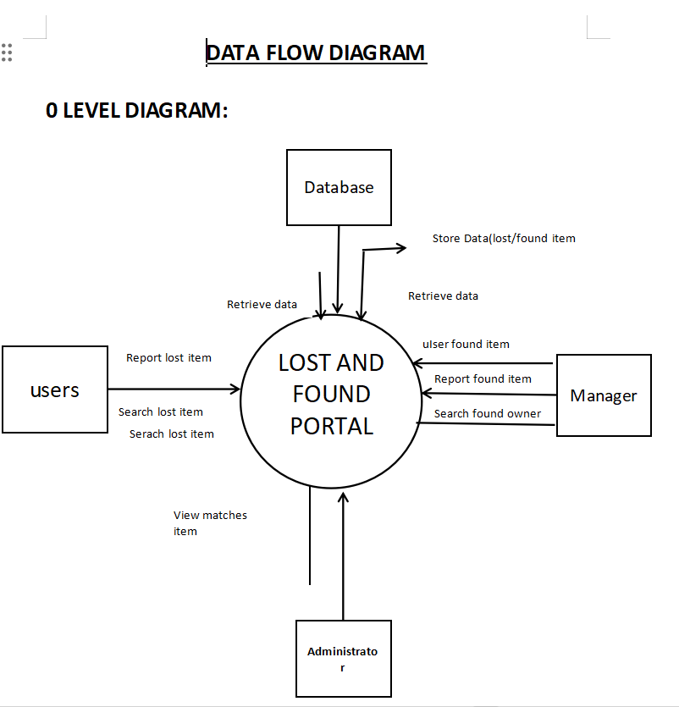

3.2 Sub-System / Component / Module Level Architecture
- User Module : registration , login , account settings
- Lost item Module : submit/review lost item reports
- Found item Module : submit/review found item reports
- Search Module : match and filter items
- Admin Module : manage and verify reports
- Notification Module : send alerts to users
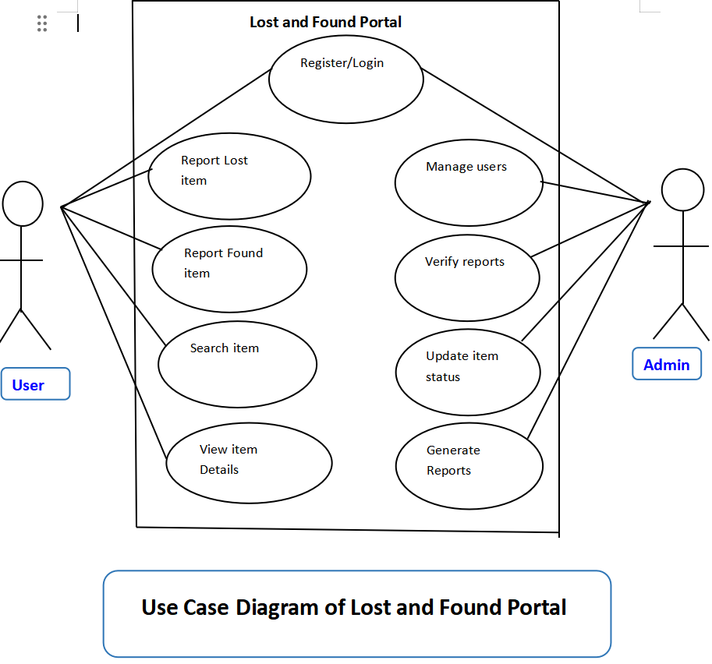

3.3 Sub-Component / Sub-Module Level Architecture (1…n)
Examples:

- Lost item Module input validator , data saver
- Search Module keyword matcher , filter processor

Design Strategie

  - Object- Oriented design Classes are clearly separated and easy to update.
  - Layered Architecture Reduces complexity and increases maintainability.
  - Simple user interface Designed to be cleaned and easy for students and staff.
  - Security Measures Basic protection of user data and controlled admin actions.

Detailed System Design

Class Diagram:

- User: user ID , name , email , password , role
- Lost item: itemID, name , description , date , location , status
- Found item: itemID , name , description , date , location
- Admin: adminID , permissions
- Notification: notificationID , message , date , Time
- Search Service: match items() , filters

Sequence Diagram:

Submitting a Lost item:

1.User login
2.Opens Lost item form
3.Enters details
4.System validates input
5.Database stores data
6.User receives confirmation

Matching process:

- Lost item added
- System checks founds records
- If match found notification sent

State Diagram:

Created Under review Matched Closed

ERD Description

Tables : Users , Lost item , found item , Notifications , Matches
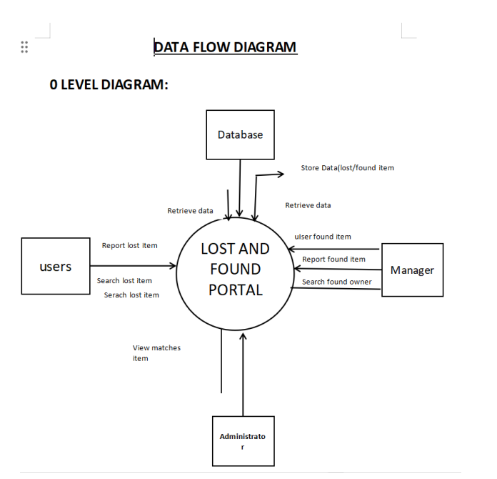

Physical data Model:

- MySQL database
- Indexing for faster searches

UI Design Overview
- Login page
- Dashboard
- Submit Lost/Found item
- Search page
- Admin Panel

References

Ref. No. | Document Title | Date of Release/ Publication | Document Source
PGBH01-2025-Proposal | Project Proposal | 17 Dec, 2025 | https://github.com/Malaika-098/lost-and-found-portal
PGBH01-2025-FS | SRS | 17 Dec 2025 | https://github.com/Malaika-098/lost-and-found-portal
 | DFD | 17 Dec 2025
 | Use Case | 17 Dec 2025

